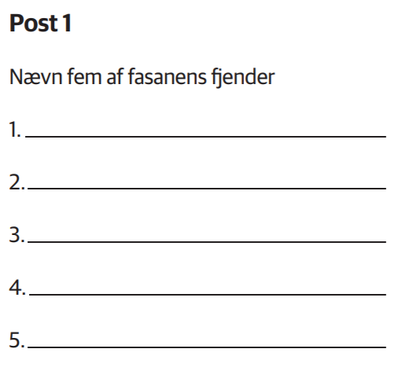

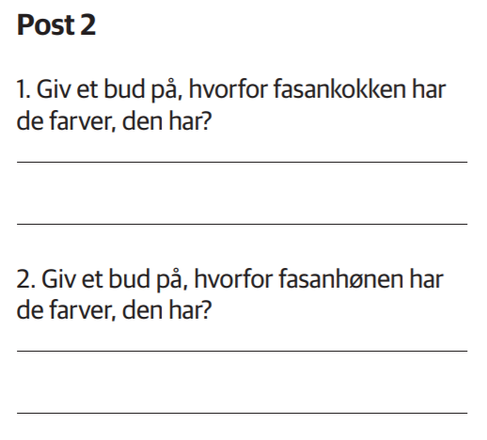

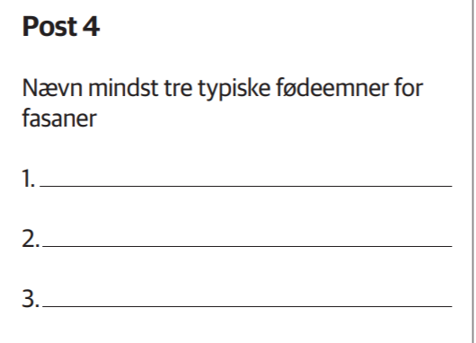

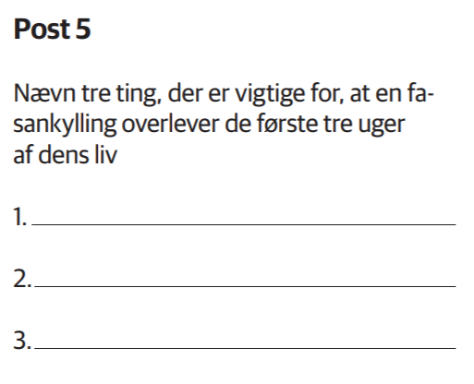

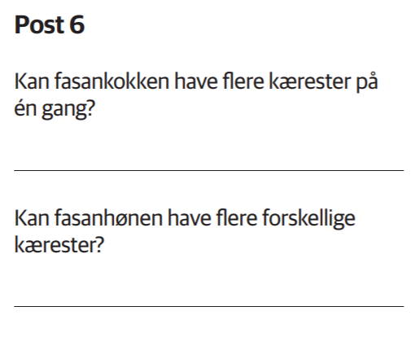

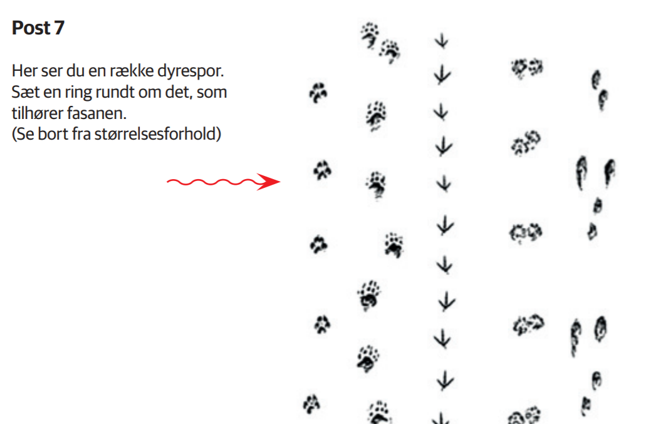

1 2 3 4 5

**Fasanquiz 1**

Navn:_________________________________

|  |  |
| --- | --- |
| Post 1 |  |
| Post 2 |  |
| Post 3 |  |
| Post 4 |  |
| Post 5 |  |
| Post 6 | Fasankok ja/nej  Fasanhøne ja/nej |

**Fasanquiz 2**

Navn:_________________________________

|  |  |
| --- | --- |
| Post 1 |  |
| Post 2 | 1.  2. |
| Post 3 |  |
| Post 4 |  |
| Post 5 |  |
| Post 6 | Fasankok ja/nej  Fasanhøne ja/nej |